Cooperation is present in a myriad of species, and researchers have used social networks to model cooperative interactions and simulate its evolution. Deriving from how young animals interact with individuals associated with their parents, a variant of that model allows newborns to inherit some parental contacts’ connections. However, that model found cooperation was only present in a limited set of conditions, posing the question of what modifications would make it better reflect real outcomes. This study’s first part assigned newborns separate probabilities to connect with cooperators and defectors (for each paternal and non-paternal contacts) and allows natural selection to act upon them. Secondly, this study implements a spatial structure restricting which individuals are eligible to reproduce and fill a population gap, and a separate structure exponentially reducing the likelihood to form connections with physical distance. It was found that allowing discrimination between cooperators and defectors for parental contacts greatly increased cooperation frequency, creating a previously-unseen region with a high degree of connectedness. However, cooperation collapsed when this discrimination was extended to non-parental contacts. Implementing just the reproduction-based spatial structure decreased cooperation frequency and resulted in a more interconnected graph, but the connection-based spatial structure showed opposite trends. Both allowing newborns to discriminate between cooperators and defectors for parental contacts and implementing a connection-based spatial structure rescues cooperation and allows the model to better reflect real-world outcomes, but more research is needed to continue investigating other spatial structures.

**Effects of Inheritance Discrimination and Spatial Structures on Cooperation in an Evolving Social Network**

Cooperation is present in a myriad of species, but must have evolved at some point. Simulations involving the evolution of cooperation incorporate two cooperation styles: cooperation or defection. Cooperators incur a penalty to provide larger benefits to other individuals, while defectors do not incur that penalty nor provide benefits to other individuals (Salathé, 2016)

| Payoff Matrix for Individuals A and B | A Cooperates | A Defects |
| --- | --- | --- |
| B Cooperates | A: 6, B: 6 | A: 8, B: -2 |
| B Defects | A: -2, B: 8 | A: 0, B: 0 |

Figure 1. Example of the Prisoner’s Dilemma for two individuals who may choose to cooperate or defect. Regardless of whether individual A chooses to cooperate or defect, individual B will have a higher payoff defecting, and individual A will have a higher payoff when defecting regardless of individual B’s choice. However, each individual would have a higher payoff if they both chose to cooperate.

In evolutionary biology, the most successful strategy will prevail, regardless of whether individuals are consciously acting (Axelrod, 1984). Previous research has found many ways to make cooperation evolutionarily favorable, however many of these models are conditional. The evolutionary development of social networks has become a focal point for research about the evolution of cooperation (Pinter-Wollman et. al, 2013).

One particular model for the evolution of cooperation within a social network of fixed size begins with the death of an individual. A child replaces that individual in the network, with newborns being assigned a parent and inheriting that parent’s cooperation strategy, with a chance of mutation (Zukewich et. al, 2013). Newborns form connections both from maternal contacts and randomly, with separate probabilities for each (which will be denoted as PN and PR respectively), a model that captures the behavior of many real-life species (Ilany et. al, 2016). Allowing the probabilities PN and PR to evolve separately results in cooperation being significantly more favored when the cost of forming connections is higher relative to the benefit of cooperation, while both PN and PR have evolved to very low values, indicating a social network with few connections but high levels of cooperation (Akçay, 2018).

Akçay’s research leaves the question of why cooperation is not more favored unanswered, as only a small and restrictive set of inputs result in high levels of cooperation. This study will introduce two new probabilities to determine inheritance: PND and PRD, the probabilities for a newborn to inherit connections with defectors that connect and do not connect with its parents respectively. It allows those probabilities to evolve separately from the probability to inherit connections with cooperators (denoted PNC and PRC for maternal contacts and random connections, respectively). The results from running simulations with these modifications will be discussed.

Secondly, this study introduces a toggleable spatial structure into the model. In Akçay’s 2018 study, parents for newborns are selected by a weighted sample of the entire population’s fitnesses. Thus, a death in any location within the population would give all individuals a chance to reproduce and fill that void, a scenario that may not be realistic given how a population is distributed. This study modifies the parent selection process by allowing specification of a range for individuals to be considered for selection as parents. Only individuals within that distance (denoted neighborRange) from the newborn will be included in the weighted sample of fitnesses. This is facilitated by individuals spatially distributed on a circle or torus, with each having a unique position on it. The results from implementing this spatial structure will be discussed within the study.

**Method**

**Inheritance Discrimination**

Code equivalent to the model developed by Akçay served as the basis for this study, with all code and modifications being written in Julia. As aforementioned, that model utilized separate probabilities for a newborn to form connections with individuals linked to its parents (PN) and with random individuals (PR) (Akçay, 2018). In this study, PN and PR were divided into two separate probabilities each, allowing newborns to discriminate between cooperators and defectors.

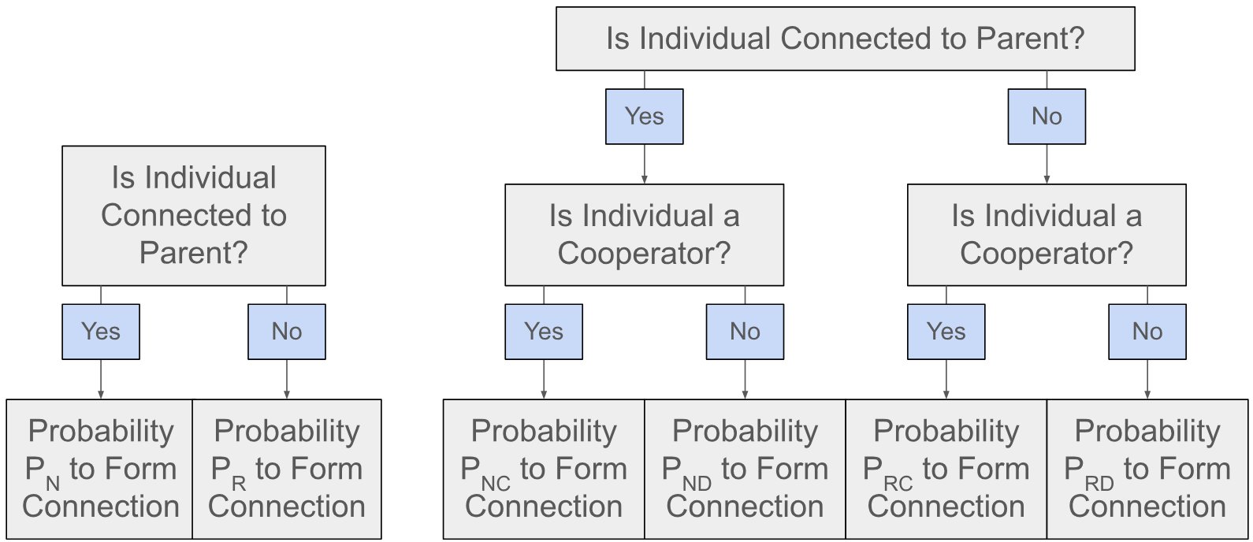

Figure 2. Comparison between Akçay’s model (left) and the model with inheritance discrimination (right). The flowchart depicts which probability will determine whether a newborn will connect with a certain individual in the population. The modifications allow newborns to discriminate between cooperators and defectors while forming connections.

At birth, each of the newborn’s inheritance probabilities (PNC, PND, PRC, and PRD) was allowed to mutate from the newborn’s parent’s inheritance probabilities with probability . Two variables, *pnd* and *prd*, were implemented and determine whether PNC and PND may evolve separately from each other and whether PRC and PRD may evolve separately, respectively. The model was run with different combinations of *pnd* and *prd* across different levels of benefits and costs to form connections to discern the effects of allowing the separate evolution of probabilities for connecting with cooperators and defectors.

**Spatial Structure**

All individuals in the population were given a unique integer location, between 1 and the population size. The distance between individuals was defined as the difference between their locations, including over/under the population size (in a population of 100, the distance between individuals 1 and 100 is 1).

A variable *neighborRange* was implemented to restrict which individuals are considered to reproduce, with only individuals within a distance of *neighborRange* from the newborn having their fitnesses considered in the weighted sample to select a mother. Low values of *neighborRange* emulate physical location having a strong effect on the population, with little migration of children from parents. The model was run across different values of neighborRange and levels of benefits and costs to form connections to discern the impact of the strength of a spatial structure on the network.

Another modification that would emulate a spatial structure was added and toggled through a newly-defined variable *distFactor*. If that structure was enabled, the probability to form a connection with an individual exponentially decreased as its distance from the newborn increased, with a connection to an individual of distance *n* from the newborn occurring at a probability of . The network’s initialization was modified where connections were formed by sampling a weighted average of *distFactor* exponentiated to the distance between individuals, rather than randomly assigning connections.

**Tracking Variables**

More metrics were added to the original model to reveal a more complete picture of the networks at each input. All of the following metrics were calculated with Julia’s Graphs package, after converting the matrix storing connections into a Graph object. Mean shortest path was calculated by averaging the distance along the social network between any two individuals using Dijkstra’s algorithm, excluding any individuals without connections. The number of connected components and size of the largest and average connected components were directly calculated from the connection matrix’s Graph.

**Results**

**Inheritance Discrimination**

Without inheritance discrimination, cooperation frequency is only favored in the region with high costs of forming connections and low benefits of cooperation. That region saw a very disconnected network, with a single-digit degree and near-zero values of PN and PR indicating that each individual was rarely connected with individuals beside their parent (Fig. A1).

When allowing inheritance discrimination for parental contacts, that region of high levels of cooperation but low degree remained, and cooperation generally increased by a moderate amount throughout the range of costs and benefits tested. However, a new region of high cooperation emerged in the low cost of linking and high benefits of cooperation area. PNC evolved to be nearly 1.0 in that region, while PR evolved to be around or above 0.5. These high levels of PNC and PR resulted in individuals inheriting most of their parent’s connections with the end result being each individual is connected to a majority of other individuals, evidenced by degree evolving to be nearly equal to the population size (Fig. A2).

When inheritance discrimination was extended to all individuals, cooperation collapsed across most of the range of costs and benefits. The incentive for a newborn defector to connect with a random cooperator was too high to promote cooperation; PRC evolved to relatively high levels throughout the range of costs and benefits, indicating that newborns connected with a significant portion of random cooperators. The one region where cooperation was favored was where the benefits of cooperation greatly exceeded the costs of linking. That region acted similar to the same region when inheritance discrimination only applied to parental contacts; with each individual being connected to the majority of others, there were few random connections to be made, and allowing PRC and PRD to evolve separately did not have a large effect on the region’s cooperation frequency, degree, and PNC values (Fig. A3).

**Spatial Structure**

When a strong spatial structure is implemented (with only individuals adjacent to the dead individual competing to reproduce), cooperation significantly decreases in all but the lowest cost regions. At high and low benefits, however, there tend to be different trends for PN, mean connected component size, and degree. At higher benefits, the spatial structure depressed PN, while the spatial structure favored higher values of PN at lower benefits. At high benefits of cooperation and medium cost of linking, degree significantly decreased from this spatial structure, but it generally increased in other areas. Mean connected component size increased in the high cost and low benefit region compared to the model without a spatial structure, but there were minimal differences at higher benefits (Fig. A4).

When run over a range of strengths of the spatial structure at low benefits, even moderately-strong spatial structures had similarly negative effects on cooperation compared to neighborRange=1. However, the strength of the spatial structure has a much larger impact on PN and PR, with PN evolving similarly to the model without a spatial structure if neighborRange is above around 19, and the spatial structure’s effect on increasing PR peaked around neighborRange=14. The spatial structure significantly increased degree at smaller neighborRanges. With fewer individuals having their fitnesses compared to select a mother, the effective strength of selection for or against cooperation is reduced. As PN evolved higher with this spatial structure, the resulting network is more interconnected as newborns inherit more of their parents’ connections, advantaging defectors in that population (Fig. A5).

At high benefits, the effects of the spatial structure’s strength varied. For cooperation frequency, its negative effect quickly diminished as neighborRange increased above 9. PN and PR showed similar trends, where only the smallest values of neighborRange had a consistent, large impact on their final values in comparison to runs without a spatial structure. There was almost no effect on mean connected component size at higher benefits, and the difference between degrees produced relatively random results without any clear trends, likely because degree was already very high in that region (Fig. A6). The weaker effects of the spatial structure at higher benefits may arise from the fact that individuals were already connected to a larger number of individuals, and the impact of the spatial structure is thus limited.

When distance-based inheritance was enabled, its effects compared to a run with neighborRange=1 (with benefits of cooperation being 2.0) varied by cost of linking. At low costs of linking, cooperation frequency did not change until distFactor was below 0.9. However, at high costs of linking, even a small decrease of distFactor from 1.0 to 0.975 quickly increased cooperation frequency. PR significantly increased in regions of low cost of linking, indicating that individuals were pressured to seek more random connections as distance played a stronger effect in limiting the likelihood connections are passed down. PN increased with the initial drop in distFactor, counterbalancing the effect of distFactor limiting how many connections can be passed down. Degree decreased throughout all levels of CL, which is unsurprising as lower levels of distFactor exponentially diminish the probability that connections of further-away individuals are inherited (Fig. A7).

**Conclusions**

**Inheritance Discrimination**

As shown by figures A1 and A2, allowing inheritance discrimination for neighbors rescued cooperation in the low cost and high benefit region. This can be attributed to the benefits of cooperation outweighing the costs in a way that incentivizes a highly connected social network. As almost all individuals are connected with each other, there is little selective pressure on PR, allowing individuals to essentially filter out all defectors when forming connections. The impact of PND and PNC evolving separately is less large in other regions, as each individual is connected to a smaller portion of other individuals.

However, when extending inheritance discrimination to random connections instead of only paternal contacts, cooperation collapses. If newborns can screen all individuals for their cooperation status, there is no drawback towards a newborn defector seeking to connect with many non-parental contact cooperators.

**Spatial Structure**

The first type of spatial structure (where candidates to reproduce were restricted to being within a range from the newborn) decreased cooperation for almost all combinations of benefits and costs of linking. This spatial structure likely created a practical decrease in selection pressure. Since fewer individuals have their fitness compared for reproduction, natural selection has a weaker effect on the population. This would weaken all of the factors promoting high levels of cooperation and would explain the similar trends shown to Akçay’s study when high and low selection pressures were compared (Akçay, 2018).

Predictably, implementing distance-based inheritance decreased the connectivity of the graph. Newborns are increasingly likely to lose connections with further away individuals after each generation, even if PN has evolved to be high. This creates a similar effect as an increase in CL does on the degree of connections. As each individual is connected with fewer others, cooperators closely connected to other cooperators are favored and will be most likely to reproduce.

**Limitations**

A limitation of this particular model is that all connections are formed as newborns. An adult has no ability to prune their connections, or otherwise reject a newborn’s attempt to connect with them. To connect the findings of this study with other research in the field, these features could be implemented into this model and check if similar trends are shown.

As the reproduction-based spatial structure decreases cooperation throughout the range of costs and benefits, it may not accurately represent what is found in the real world. Different variations of spatial structures should be investigated, including an exponential model for reproduction rather than a hard cutoff at a certain range. The strength of the spatial structure could also be allowed to evolve, representing a population’s mobility independently evolving.

**Appendix A - Results Graphics**

**Inheritance Discrimination**

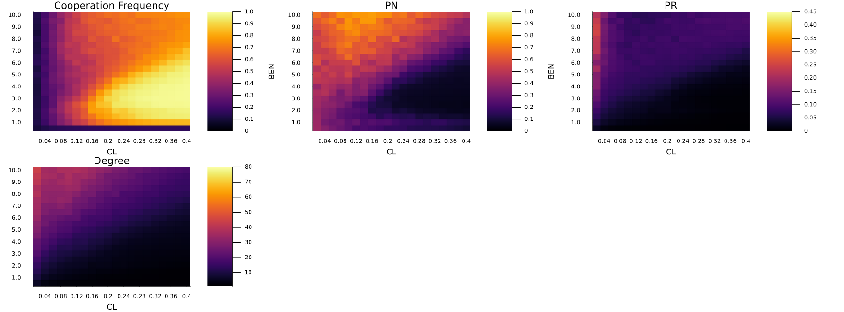Figure A1. Cooperation Frequency, PN, PR, and Degree over a range of costs of linking (CL) and benefits of cooperation (BEN) and other inputs (C=0.5, gen=100000, pn0=0.5, distInherit=false, pr0=0.0001, μ=0.01, δ=0.5, σpn=0.01, σpr=0.01, reps=50), with no inheritance discrimination (PNC=PND and PRC=PRD). The population size was 100.

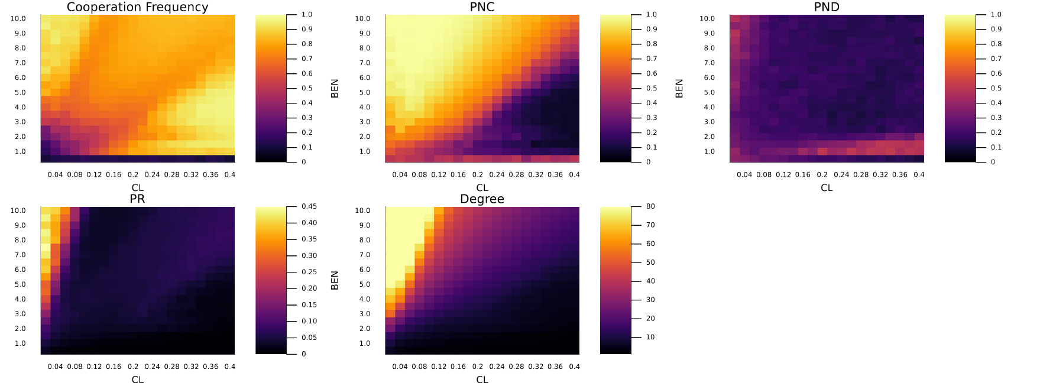

Figure A2. Cooperation Frequency, PNC, PND, PR, and Degree over a range of costs of linking (CL) and benefits of cooperation (BEN) and other inputs (C=0.5, gen=100000, pn0=0.5, distInherit=false, pr0=0.0001, μ=0.01, δ=0.5, σpn=0.01, σpr=0.01, reps=50), with inheritance discrimination for only paternal contacts (PNC≠PND and PRC=PRD). The population size was 100.

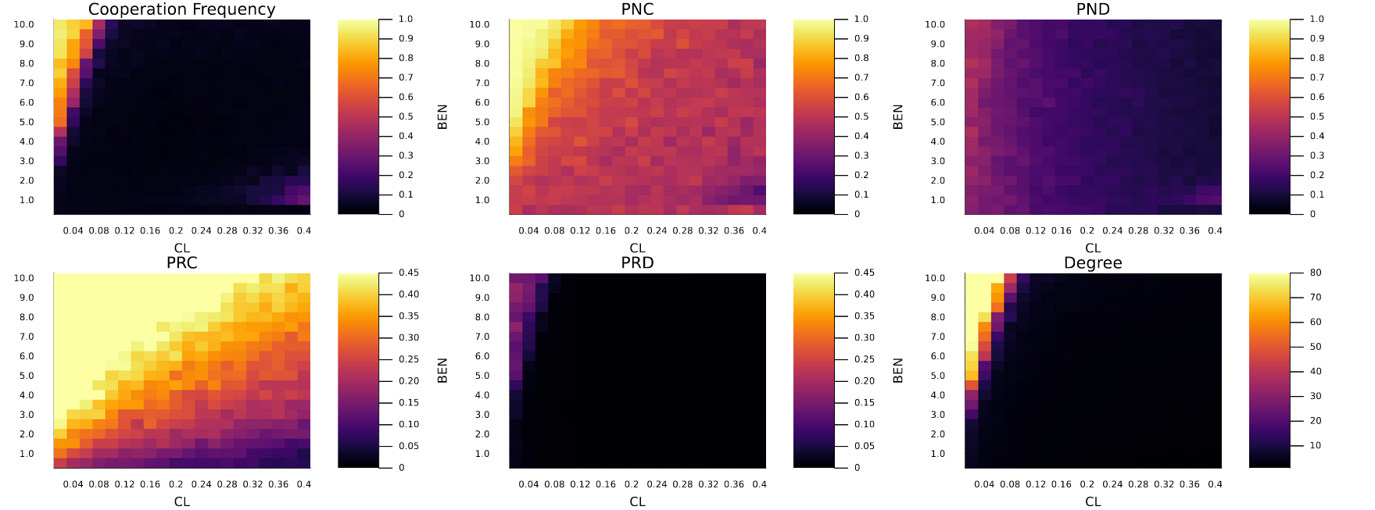

Figure A3. Cooperation Frequency, PNC, PND, PRC, PRD, and Degree over a range of costs of linking (CL) and benefits of cooperation (BEN) and other inputs (C=0.5, gen=100000, pn0=0.5, distInherit=false, pr0=0.0001, μ=0.01, δ=0.5, σpn=0.01, σpr=0.01, reps=50), with inheritance discrimination for all individuals (PNC≠PND and PRC≠PRD). The population size was 100.

**Spatial Structure**

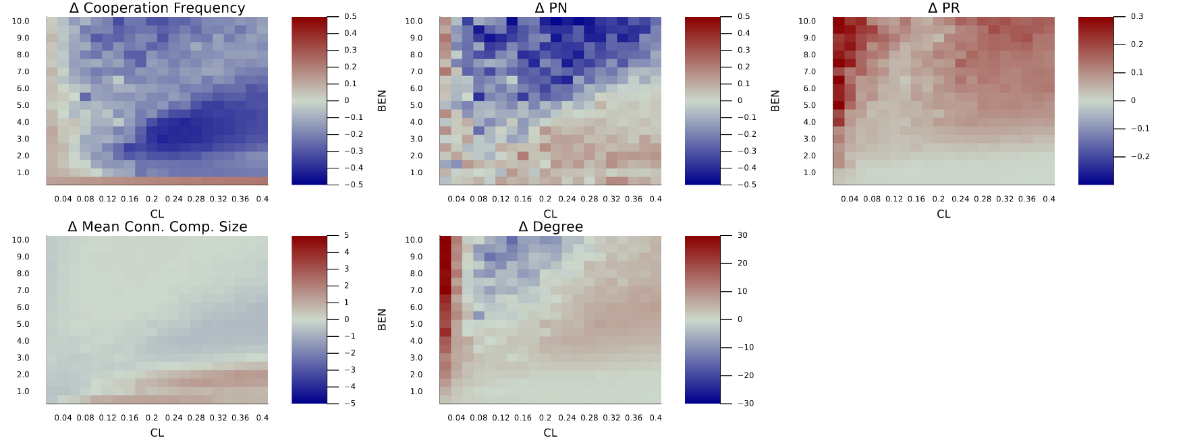

Figure A4. Difference between a strong spatial structure (neighborRange=1) and no spatial structure (anyMom) over a range of costs of linking (CL) and benefits of cooperation (CL), with other inputs (C=0.5, gen=100000, pn0=0.5, distInherit=false, pr0=0.0001, μ=0.01, δ=0.5, σpn=0.01, σpr=0.01, reps=10, population size = 100) being held constant. There was no inheritance discrimination (PNC=PND and PRC=PRD).

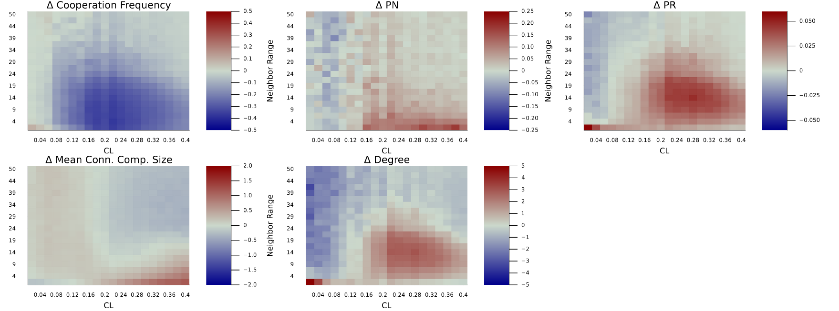

Figure A5. Difference of cooperation frequency, PN, PR, mean connected component size, and degree at low benefits of cooperation between various strengths of spatial structure and no spatial structure, over a range of neighborRange (with 50 being identical to anyMom) and costs of forming connections (CL), with other inputs (B=2.0, C=0.5, gen=100000, pn0=0.5, distInherit=false, pr0=0.0001, μ=0.01, δ=0.5, σpn=0.01, σpr=0.01, reps=50, population size = 100) being held constant. There was no inheritance discrimination (PNC=PND and PRC=PRD).

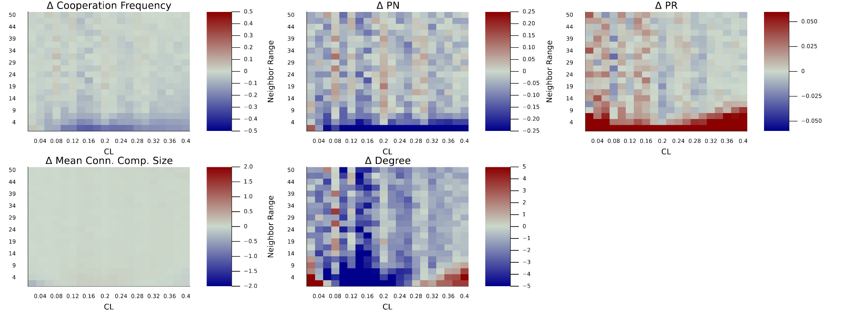

Figure A6. Difference of cooperation frequency, PN, PR, mean connected component size, and degree at high benefits of cooperation between various strengths of spatial structure and no spatial structure, over a range of neighborRange (with 50 being identical to anyMom) and costs of forming connections (CL), with other inputs (B=9.0, C=0.5, gen=100000, pn0=0.5, distInherit=false, pr0=0.0001, μ=0.01, δ=0.5, σpn=0.01, σpr=0.01, reps=50, population size = 100) being held constant. There was no inheritance discrimination (PNC=PND and PRC=PRD).

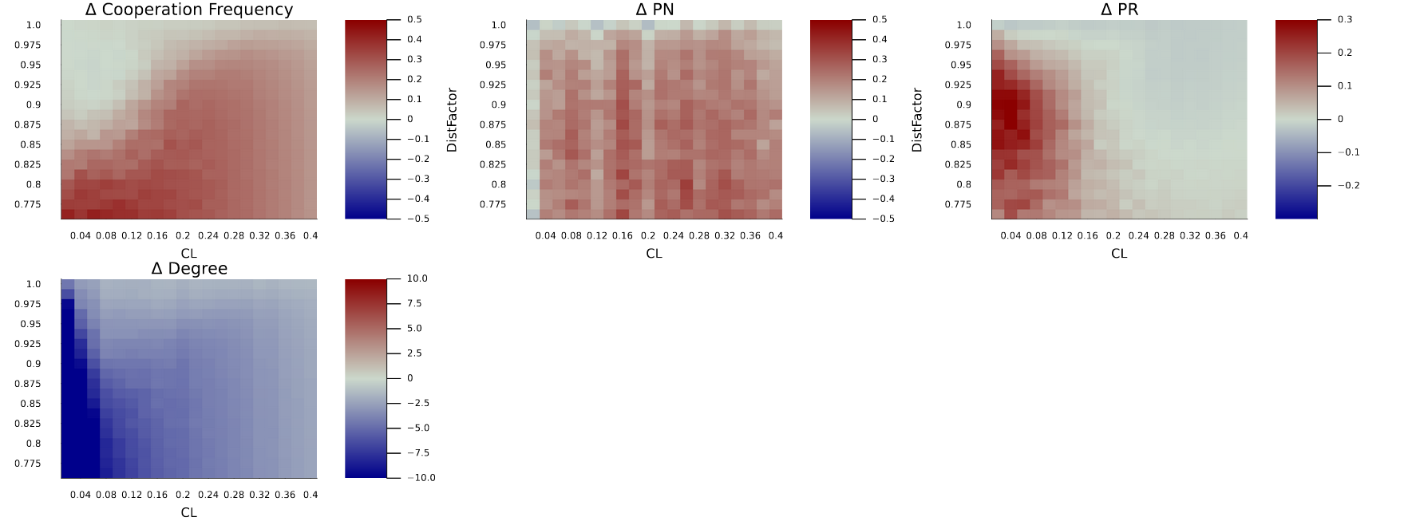

Figure A7. Difference of cooperation frequency, PN, PR, and degree between distance-based inheritance and a strong spatial structure, over a range of distance factors and cost of linking (CL), with other inputs (B=2.0, C=0.5, gen=100000, pn0=0.5, neighborRange=1, pr0=0.0001, μ=0.01, δ=0.5, σpn=0.01, σpr=0.01, reps=10, population size = 100) being held constant. There was no inheritance discrimination (PNC=PND and PRC=PRD).